zVarni Infotech

An Internship Report Submitted to

UKA TARSADIA UNIVERSITY

Final Year Student of
Diploma
in
Information Technology

By
Devganiya Akash Keshavbhai
(202302100710015)

Guided by
Mr. Bhagirath Dhanani
CEO

Ms. Ketana Tandel
Assistant Professor


Department of Computer Engineering
Chhotubhai Gopalbhai Patel Institute of Technology
Bardoli, Surat, Gujarat
November 2025

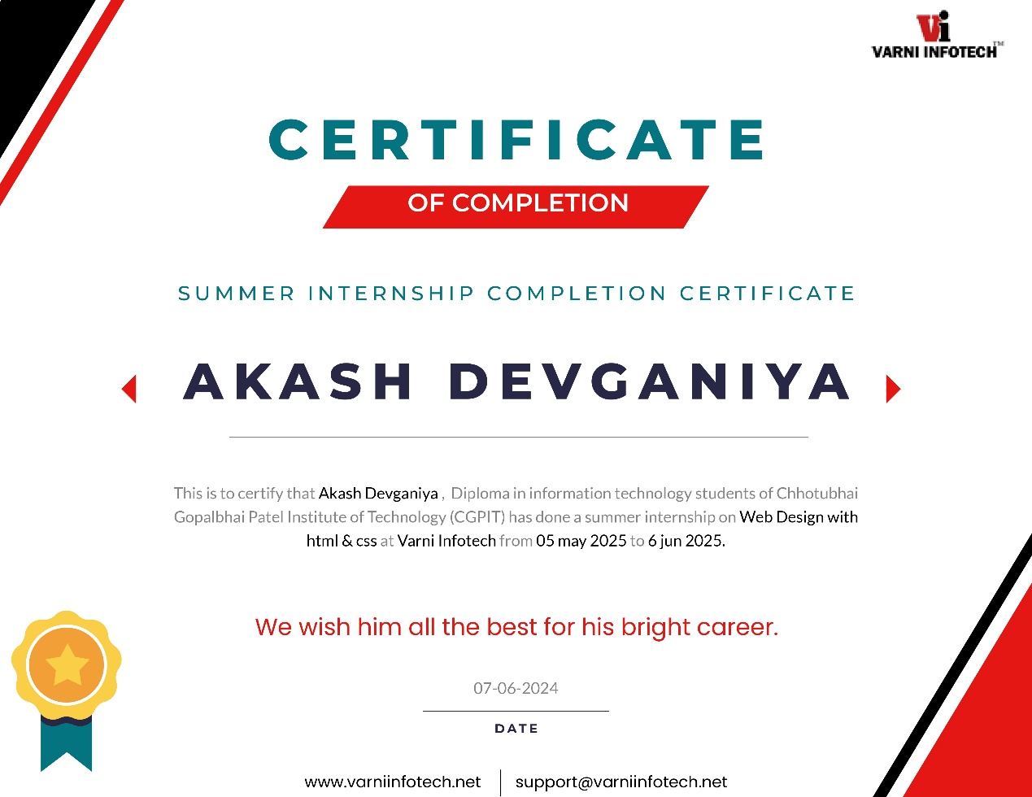

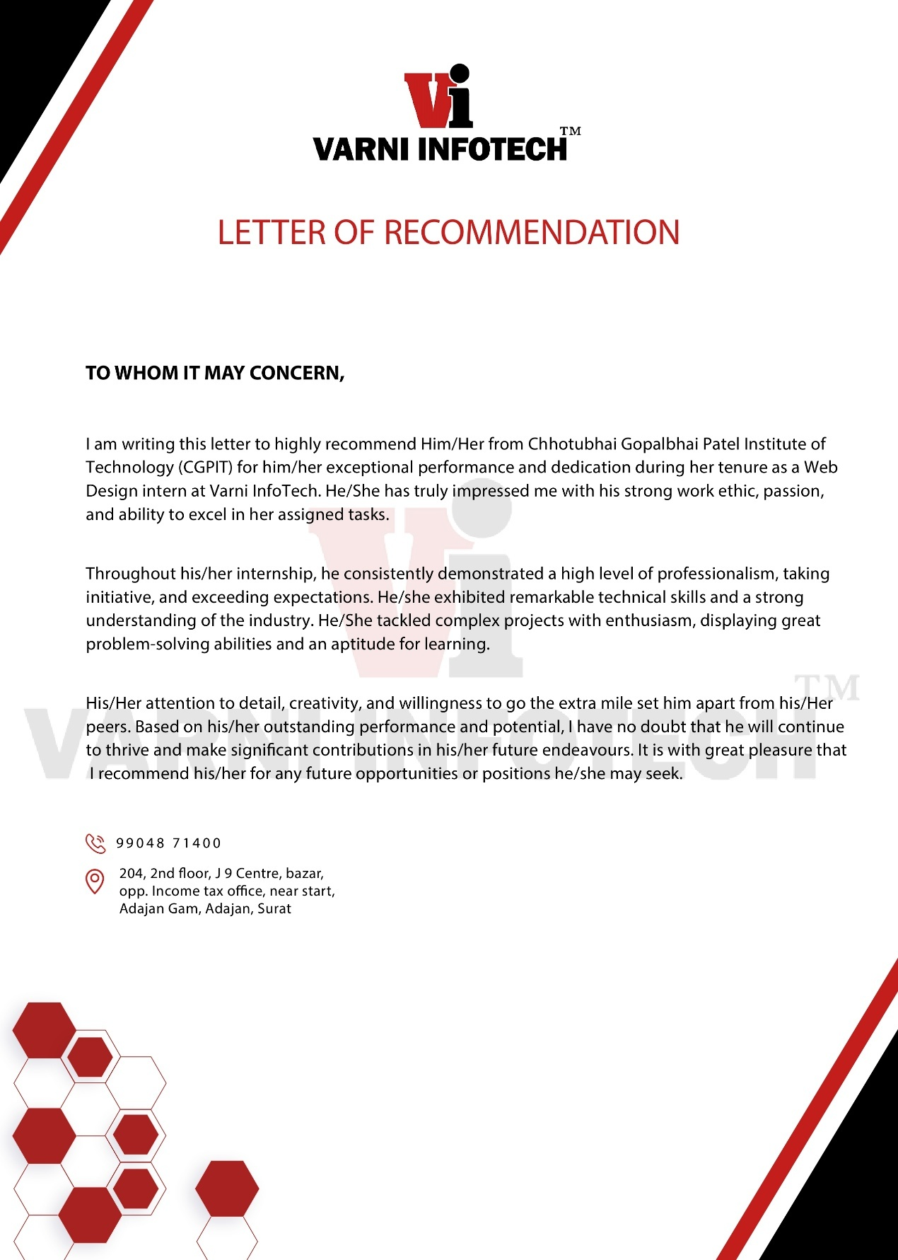

EVALUATION BY EXTERNAL GUIDE

Information about external supervisor/mentor/guide of Intern student
Name | Bhagirath Dhanani | Contact No | 9904871400
Name of Organization | Varni Infotech | Email Address:  dhanani_bhagirath@yahoo.com
Job Title/Designation | CEO

Intern Student details
Enrollment No | Name of the student | Course/Semester | Project Title/Internship Name | Start date | End date
202302100710015 | Akash.K Devganiya | Diploma In IT | Web Designing | 05/05/2025 | 06/06/2025

Intern/Student Evaluation/Assessment Criteria
Sr. No | Evaluation criteria | Excellent  (5) | Very Good (4) | Satisfactory  (3) | NeedsImprovement (2) | Unsatisfactory  (1)
1 | Punctuality | √
2 | Behaved in a professionalmanner |  | √
3 | Effectively performed  Given Assignments | √
4 | Oral communication skills | √
5 | Written communication skills | √
6 | Ability to work with others | √
7 | Ability to adapt to a variety of tasks
8 | Reliability | √
9 | Dependability | √
10 | Attention to accuracy and details |  | √
11 | Willingness to ask for help and guidance | √
12 | Demonstrated critical thinkingand problem solving skills | √
13 | Quality of work |  | √
14 | Seemed interested and in andenthusiastic about the internship experience |  | √
15 | Analytical thinking |  | √

Qualitative review/Assessment:

Sr. No | Qualitative Assessment Criteria
1 | Comment about the approach of Intern/students towards problem solving
2 | Suggestions for making internship program more effective and value added
3 | Specific observation(s) which will help to improve the quality of intern/student

Signature of Supervisor/Guide/Mentor | Date
 | 18/09/2025

EVALUATION BY INTERNAL GUIDE

Information about internal supervisor/mentor/guide of Intern student
Name | Ketana Tandel | Contact No | 9998387889
Designation | Assistant Professor | Email Address:  ketana.tandel@utu.ac.in
Department | Computer Engineering (Diploma)

Intern Student details
Enrollment No | Name of the student | Course/Semester | Project Title / Internship Name | Start date | End date

Intern/Student Evaluation/Assessment Criteria
Sr. No | Evaluation criteria | Excellent  (5) | Very Good (4) | Satisfactory  (3) | Needs Improvement (2) | Unsatisfactory  (1)
1 | Punctuality
2 | Behaved in a professional manner
3 | Effectively performed  Given Assignments
4 | Oral communication skills
5 | Written communication skills
6 | Ability to work with others
7 | Ability to adapt to a variety of tasks
8 | Reliability
9 | Dependability
10 | Attention to accuracy and details
11 | Willingness to ask for help and guidance
12 | Demonstrated critical thinking and problem solving skills
13 | Quality of work
14 | Seemed interested and in and enthusiastic about the internship experience
15 | Analytical thinking

Qualitative review/Assessment:

Sr. No | Qualitative Assessment Criteria
1 | Specific improvement observed in the student during your visit
2 | Details of future collaboration discussed during your meeting with HR and Industry’s guide
3 | Specific comments/suggestions

Signature of Supervisor/Guide/Mentor | Date

Industry Feedback Form

Dear Sir / Madam,

Many final year students of our Department are undergoing internship training at your organization. We are thankful to you for providing them training with your prestigious Organization.

We shall very much appreciate and be grateful to you if you can spare some of your valuable time to fill up this feedback form. It will help us to improve the Institute further and make better employees in the future.

Tick ‘√’ the number that best describes your level of satisfaction at each question:
1 – Far from satisfied
2 – Not satisfied
3 – Satisfied
4 – Happy
5 – Very happy

 | How satisfied are you with the student work performance in each of these areas: |  |  |  |  |  |  | 1 |  |  | 2 |  | 3 |  | 4 |  | 5
 | General communication skills |  |  |  |  |  |  |  |  |  |  |  |  |  |  |  | √
 | Developing practical solutions to work place problems |  |  |  |  |  |  |  |  |  |  |  |  |  | √
 | Working as part of a team |  |  |  |  |  |  |  |  |  |  |  |  |  | √
 | Creative in response to workplace challenges |  |  |  |  |  |  |  |  |  |  |  |  |  |  |  | √
 | Their planning and organization skills |  |  |  |  |  |  |  |  |  |  |  |  |  |  |  | √
 | Self-motivated and taking on appropriate level of responsibility |  |  |  |  |  |  |  |  |  |  |  |  |  | √
 | Open to new ideas and learning new techniques |  |  |  |  |  |  |  |  |  |  |  |  |  |  |  | √
 | Using technology and workplace equipment |  |  |  |  |  |  |  |  |  |  |  |  |  |  |  | √
 | Ability to contribute to the goal of the organization |  |  |  |  |  |  |  |  |  |  |  |  |  |  |  | √
 | Technical knowledge/skill |  |  |  |  |  |  |  |  |  |  |  |  |  |  |  | √
 | Ability to manage/leadership qualities |  |  |  |  |  |  |  |  |  |  |  |  |  | √
 | Innovativeness, creativity |  |  |  |  |  |  |  |  |  |  |  |  |  | √
 | Relationship with seniors /peers / subordinates |  |  |  |  |  |  |  |  |  |  |  |  |  |  |  | √
 | Involvement in social activities |  |  |  |  |  |  |  |  |  |  |  |  |  |  |  | √
 | Ability to take up extra responsibility |  |  |  |  |  |  |  |  |  |  |  |  |  | √
On a scale of 1 to 10 how do you rate your overall satisfaction with UTU students?
If you were dissatisfied with any aspect, please comment further:

How could our programs be improved? What specific comments do you have regarding the curriculum?

Any other comment(s):

Would you like to recruit / train UTU student? |  |  |  |  |  |  |  |  | Yes □ |  |  |  |  | No □
Would you refer us to other organization(s)? |  |  |  |  |  |  |  |  | Yes □ |  |  |  |  | No □
Please feel free to speak in confidence with our TPO/ staff about any aspects of the program or student’s performance. If you would like staff to contact you to discuss any issues, please provide your contact number.

Phone:

Name: Bhagirath Dhanani
Position: CEO
Company/organization: Varni Infotech
Date and Signature: 18/09/2025

ACKNOWLEDGEMENT

I would like to express my sincere gratitude to Varni Infotech for providing me with the opportunity to undertake my summer internship in the field of web designing. This internship has been an invaluable learning experience that allowed me to enhance my technical skills and gain practical knowledge.

I am especially thankful to my mentor and the entire team at Varni Infotech for their constant guidance, support, and encouragement throughout the internship period. Their insights and constructive feedback helped me to understand the real-world applications of web designing and improve my abilities.

I would also like to extend my thanks to my academic institution for their continuous support and for facilitating this internship.
Finally, I am grateful to everyone who directly or indirectly contributed to the successful completion of my internship report.

Thank you.

ABOUT COMPANY

Varni Infotech is a full-service Web Design, Web Development, Mobile Application Development Company located in Surat, Gujarat, India from 2008. We have got a talent pool of seasoned professionals taking care of wide range of services – Website Design, Web Development, Software Development, Web Maintenance, Online Marketing,e-Commerce, Mobile Application Development, Search Engine Optimization, Flash Applications, Product Presentation, Social Media Marketing and Content Writing.

Varni Infotech is committing to provide you the highest quality industry – specific design services and solution within your budget and under tightest deadlines. Our goal is to help our clients by optimizing their business process with professional design and technological solutions.

ABOUT INTERNSHIP AREA

Domain | Web Designing
Starting Date And  Ending Date | Starting Date | Ending Date
Starting Date And  Ending Date | 05/05/2025 | 06/06/2025
Mode of Internship (Offline or Online) | Offline
Live Project (Yes / No) | NO
TEAM/ INDIVIDUAL | Individual

CONTACT DETAILS

EXTERNAL GUIDE

NAME | Bhagirath Dhanani
DESIGNATION | CEO
MOBILE | 9904871400
EMAIL | dhanani_bhagirath@yahoo.com

INTERNAL GUIDE

NAME | Ketana Tandel
DESIGNATION | Assistant Professor
MOBILE | 9998387889
EMAIL | ketana.tandel@utu.ac.in

STUDENT

NAME | Devganiya Akash Keshavbhai
MOBILE | 9714087287
EMAIL | akashdevganiya5@gmail.com

Week 1: Learn HTML From W3Schools

- HTML : HTML is the standard markup language for Web pages
- All HTML documents must start with a document type declaration: <!DOCTYPE html>.
- HTML Tags : Tags are used in HTML to define elements on a webpage.
- HTML tags are written inside angle brackets like <tag>.
- Most HTML tags have an opening and a closing tag, for example: <p> ... </p>.
- HTML headings are defined with <h1> to <h6> tags.
- <h1> defines the largest or most important heading, while <h6> defines the smallest heading.
- <p> → Used to write a paragraph.
- <a> → Used to create hyperlinks (links to pages or websites).
- <img> → Used to display an image.
- <br> → Used to insert a line break (go to next line).
- <div> → Used to divide page into sections or blocks.

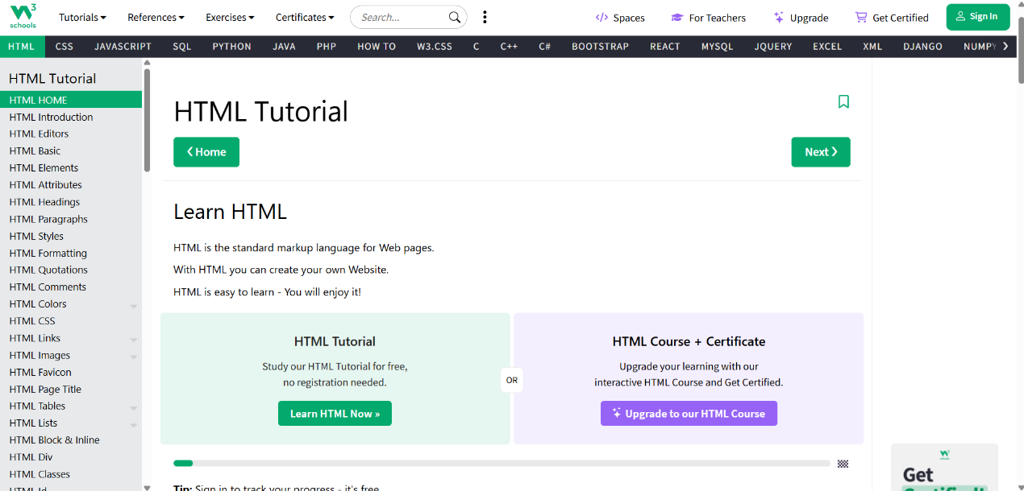

Week 2: Learn CSS From W3Schools

- CSS : Cascading Style Sheets, used to style and design HTML web pages.
- CSS helps make webpages responsive so they work on mobile, tablet, and desktop.
- With CSS, we can add animations, transitions, and effects to elements.
- CSS controls the layout, colors, fonts, spacing, and overall look of a webpage.
- CSS is used to make webpages attractive and well-formatted.
- CSS can be written in three ways: Inline CSS, Internal CSS, and External CSS.
- Inline CSS is written inside an HTML tag using the style attribute.
- Internal CSS is written inside the <style> tag in the <head> section.
- External CSS uses a separate .css file and is linked using <link> tag.
- <link> tag is used to connect external CSS to an HTML document.
- Example properties in CSS: color, background-color, font-size, margin, padding, border.

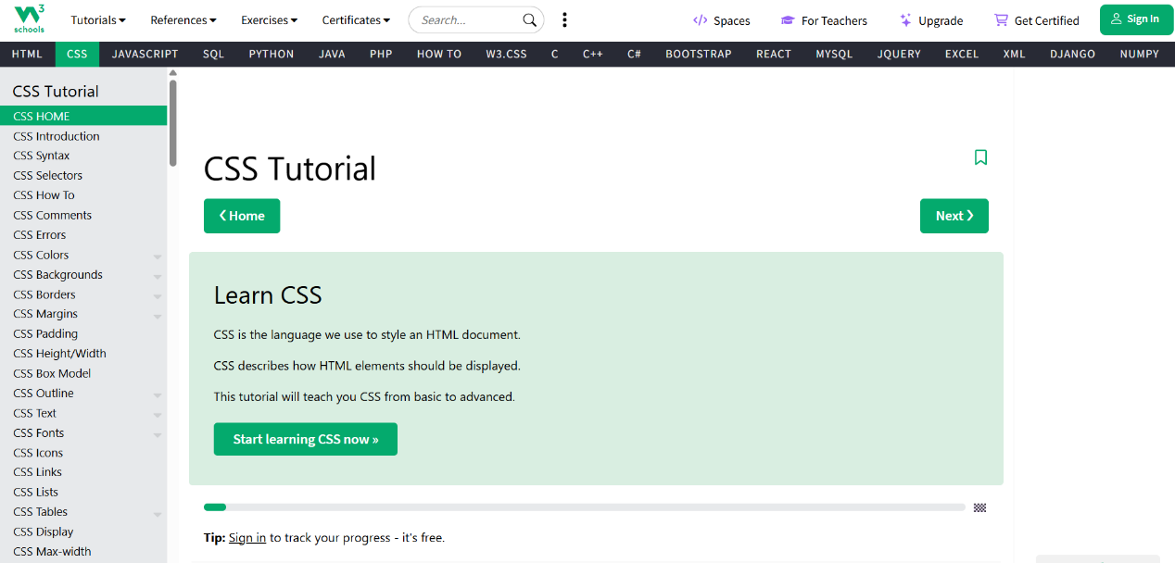

Week 3 : Create Resume With Help Of HTML & CSS

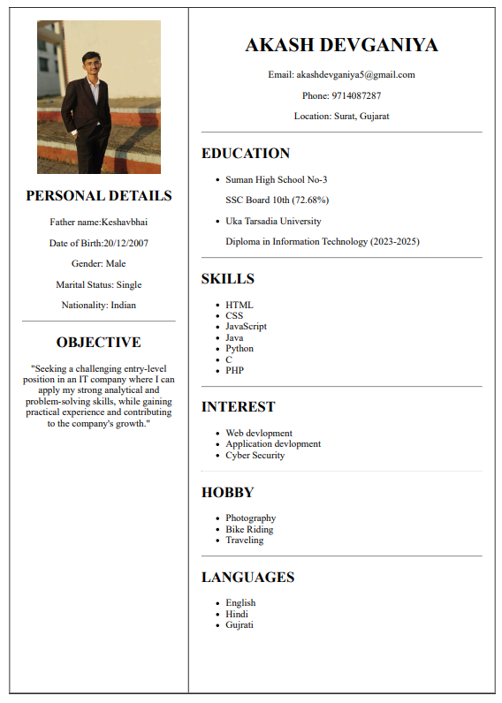
- During the internship, I created a professional resume webpage using HTML & CSS. The resume page is designed with a clean and structured layout divided into two sections: a left sidebar containing personal details and a right content area displaying education, skills, interests, hobbies, and languages.
Week 4 & 5 : Create Styles,Fully Responsive And Multiple Own Information Web Pages Website

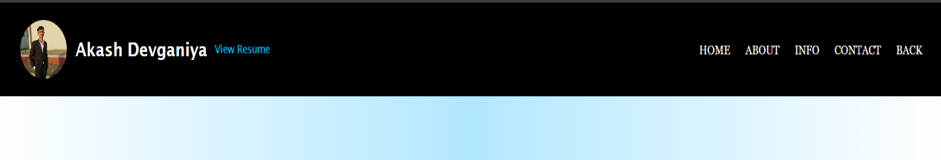
- The header section is designed to provide quick navigation across the website and display personal identity clearly. It contains two main parts:
- Profile and Name Section (Left side)
- Navigation Menu (Right side)

Home Page

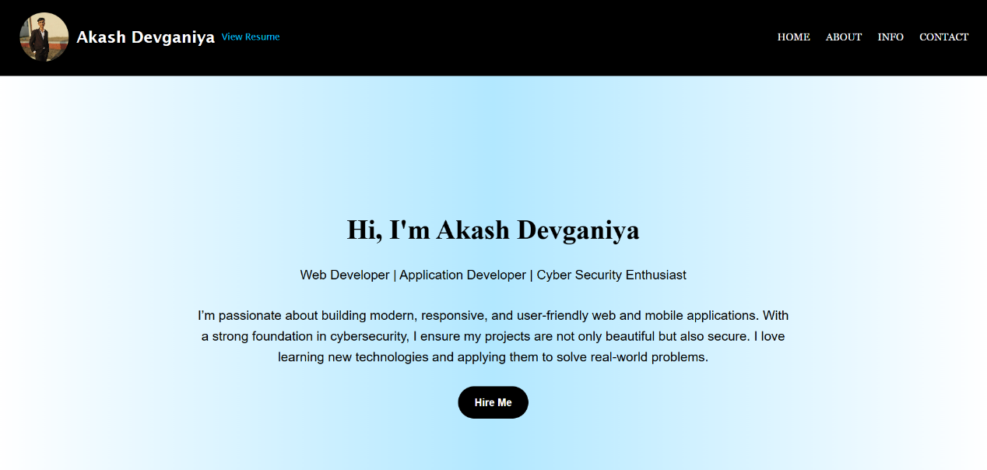

- This project is a personal portfolio website designed to showcase my professional profile, skills, projects, and contact information. The goal of the website is to create a clean, responsive, and user-friendly platform that highlights my capabilities as a Web Developer, Application Developer, and Cyber Security Enthusiast.

About Page

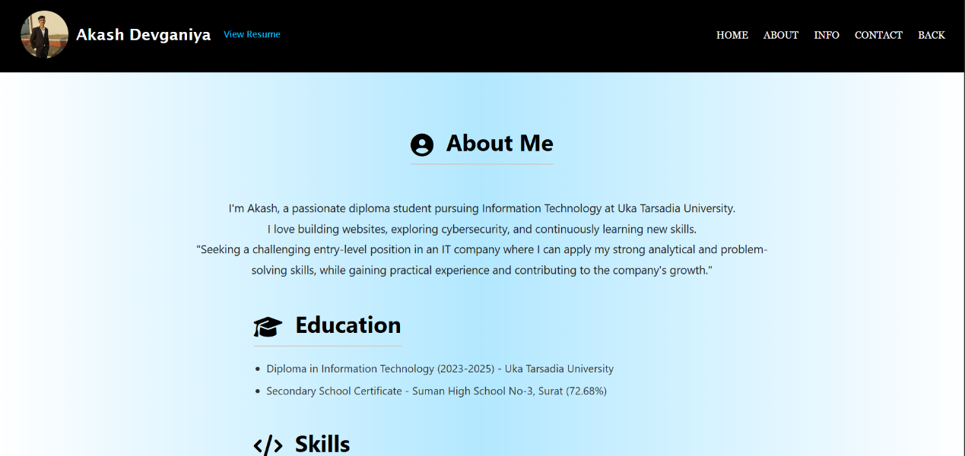

- The About Me page introduces the developer and provides an overview of personal background, education, skills, and career goals. It is one of the most important parts of the portfolio website as it helps visitors understand the developer’s identity, interests, and qualifications.

Personal Info Page : DOB, gender, nationality,career Objective,Strengths

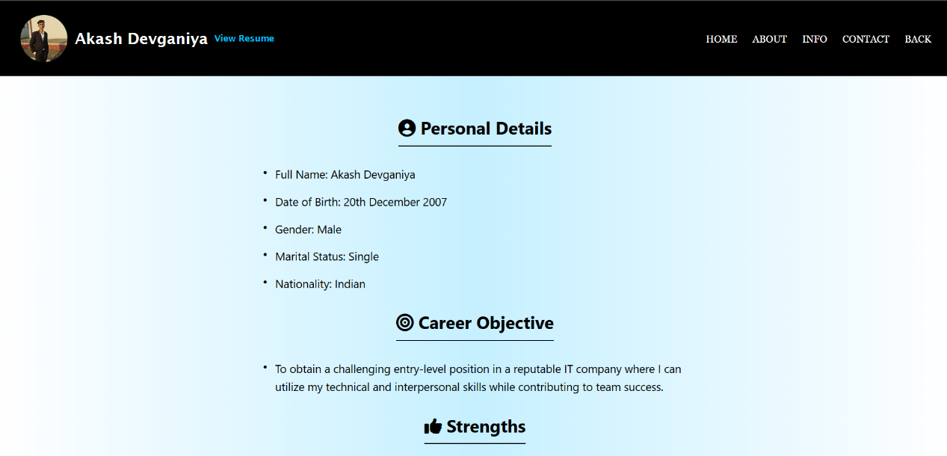

- The Personal Details page provides a structured summary of the developer’s basic personal information, career objective, and strengths. This page helps visitors gain a quick understanding of the candidate’s background, personality, and professional goals. It is an essential part of a portfolio website, especially for job-seeking students and freshers.

Contact Page

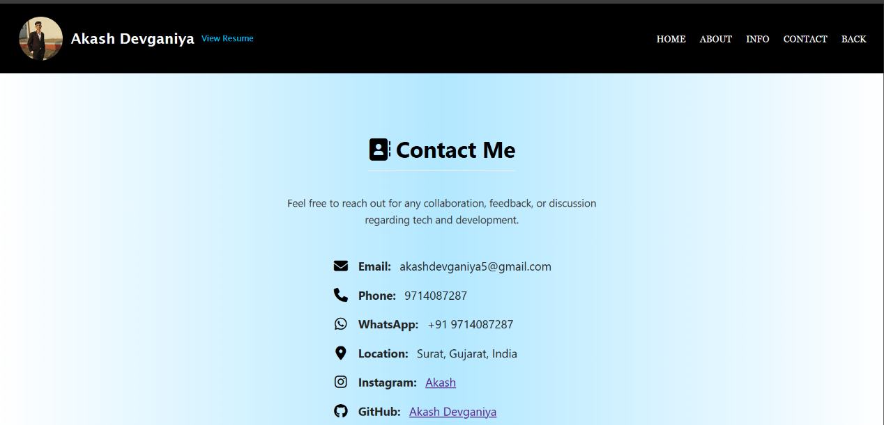

- The Contact Me page serves as the communication bridge between the developer and visitors. It provides multiple channels—email, phone, WhatsApp, social media, and GitHub—to allow students, recruiters, developers, or clients to reach out easily. The design aims to be clean, simple, and user-friendly.

Hire Me Form

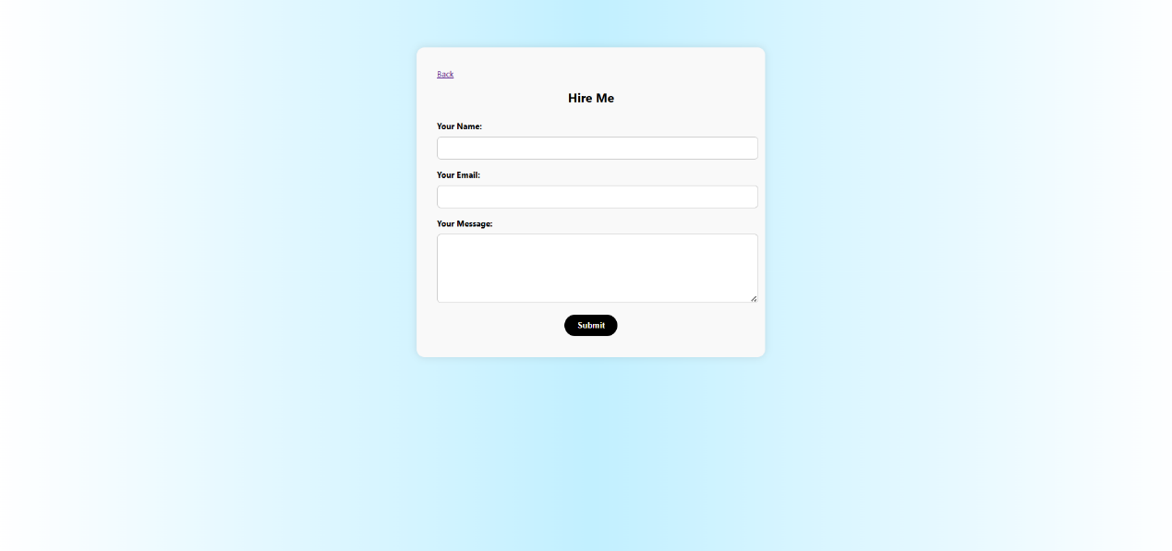

- The Hire Me page is a contact interface designed to allow visitors to reach out for collaboration, project inquiries, or freelance work. It provides an easy-to-use form where users can enter their name, email, and a message.

SUMMARY OF INTERNSHIP

I successfully completed my summer internship at Varni Infotech, where my primary focus was on Web Designing. During this internship, I gained valuable practical experience in designing and developing modern, responsive, and user-friendly websites. I learned to use various web technologies such as HTML & CSS and frameworks that are essential for creating professional websites.

The internship provided me with opportunities to work on real-time projects, where I understood how to convert ideas and requirements into attractive website layouts. I also improved my skills in designing navigation structures, applying color themes, working with typography, and ensuring mobile responsiveness.

Through this training, I enhanced my technical knowledge, creativity, and problem-solving skills. I also learned about industry standards, teamwork, and time management while handling assigned tasks. Overall, this internship helped me bridge the gap between theoretical knowledge and practical implementation, and it provided me with confidence to work on live projects in the future.

